Understanding the Parking Situation

Shared vs. Private
What is the Parking situation?

Is the parking space shared, assigned, deeded, or dedicated to a unit?

Shared Chargers
The building management or HOA installs multiple charging stations in shared spaces.

PROS
• Typically, less costly to install several shared vs. multiple dedicated chargers
• Greater utilization of shared chargers
• Eases the transition for EV purchase

CONS
• Shared chargers may require more persuasion, and/or an HOA vote
• With a limited number of shared chargers, everyone may not be able to charge at the same time
• If chargers are networked, will add cost.
• As demand increases, may need to institute time limits and/or idle fees if vehicle not moved

Private Chargers
If there is adequate power near the desired space(s), if approved by HOA or building management, and if resident is willing to pay for the installation.)

PROS
• If HOA, potentially less persuasion required especially in a “Right-to-Charge” state
• Homeowner/resident has exclusive access
• No time limits, idle fees, or moving the vehicle after charging is completed
• If a condo, the unit may command price premium when sold

CONS
• The homeowner/resident may have to pay for the installation and equipment costs
• Costs to install individual charger may be higher
• No backup if charger/circuit stops working

Follow link to Building Management webpage where Charging program design provides details
about charger location selection, charger functionality, cost recovery methods, etc.

Costs
Every building is different. And each charging solution has its own costs.

CHARGING EQUIPMENT

$
LEVEL 1

The most affordable option: No special equipment – the driver
can use the charger and cable set that came with the vehicle; the electrician simply installs a dedicated 110v/120v outlet at the charging site.

$~$$
LEVEL 2

Non-networked Level 2 charger cost $400~$700; An electrician must install 220/240-volt electrical outlet.

Non-networked Level 2 chargers with WiFi
($600 ~ $900) provide network control and information to the user.

$$$
“SMART” LEVEL 2

Networked Level 2 chargers require 220/240-volt can cost 2,000~$6,000 plus installation by a qualified electrician; when commissioned (connected to the network), it can provide usage and billing data, scheduling, and monitoring. Primarily for a shared environment.
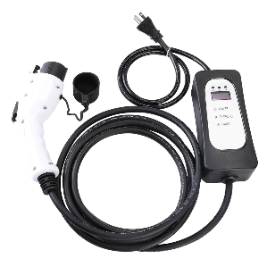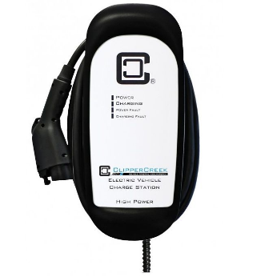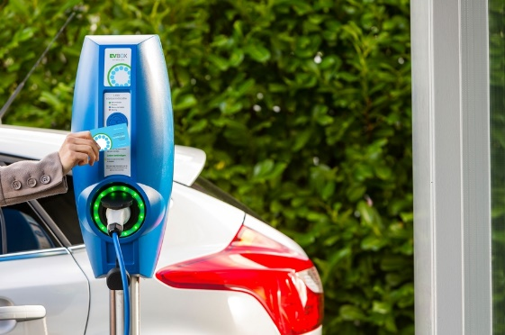
TIP!
Consider installing simple dedicated outlets or non-networked chargers with a flat monthly fee of $2 or $3 per day ($60~$90/month) per unit. This could be less costly and burdensome than a networked solution.

Note Regarding High Upfront Costs:

Financing Incentives – Database

Check PlugStar to see if there are financial incentives available for your site.

More utilities are offering special programs to encourage/support EVs. EVs have the potential of the largest growth opportunity for electricity utilities since the introduction of air conditioning after World War II.

Research available financial assistance or incentives for your site from your utility, city, or state, etc. Incentives may be available to assist with costs for equipment, installation, or both.

Even if you own your condo and parking space, you will need permission from the HOA for electrical upgrades and charger installation. HOA rules vary.

Installation

$
LOWER COST SCENARIO

If power is available near the desired or an acceptable space, and/or if it is near the existing electrical service (the electrical panel), minimal electrical work is required.

$$ ~ $$$
HIGHER COST SCENARIOS

New Service/Power is required.

The electrical service is adequate, but the electrical panel is not close to the desired parking space, requiring costly electrical runs or runs across hardscapes, sidewalks, etc.

Discuss with property management or HOA.
What to do next:
Engage a qualified electrician, identify required/available power, and electrical work required.
If limited power is available, explore multiplex (rotational) or shared power (link to systems w/functionality)
Obtain quotes from multiple providers and discuss with your electrician
Tip!
Most parking lots and building garages were not built with extra electrical capacity needed for EV charging. Costly new service, or additional service may be required. It may be very difficult and costly to install charging at a particular parking space. It is best to get a qualified electrical contractor or electrical engineer to assess the site.

Operation and Maintenance

$
LOWEST COST SCENARIO

Non-networked Level 1 or Level 2 chargers don’t have network fees. The cost of electricity could be provided by the HOA or building owner as an amenity or for a fixed flat monthly fee.

$$~$$$
HIGHER COST SCENARIO

The charger(s) is/are connected to a submeter, but individual usage is not tracked.
A networked or smart charger tracks usage, bills, and manages the charging of multiple
drivers. An ongoing monthly network subscription fee will be required.

