What You Need to Know about Charging

Determine appropriate EVSE or Charging Level
Level I: Typical Household electrical outlet (110/120 volt)
Provides 4 to 6 Miles per Hour of Charging

Level II: 220 Volt outlet (either 3.3 kW or 7.2kW)
Charges 3x to 6x faster than Level 1
Provides 10 to 30 Miles per Hour of Charging

DCFC: 440/480 Volt (50/62 kWh to 350 kWh)
Charges up to 10x faster than Level 2 and 100x faster than Level 1
Provides up to 75 to 200 Miles in a ½ Hour of Charging*
* Older EVs may not be capable of recharging this rapidly
* Some older EVs and most Plug-in Hybrids are NOT equipped or capable of DCFC

Three types of EV Charging: Level 1, Level 2, and DC Fast Charging.
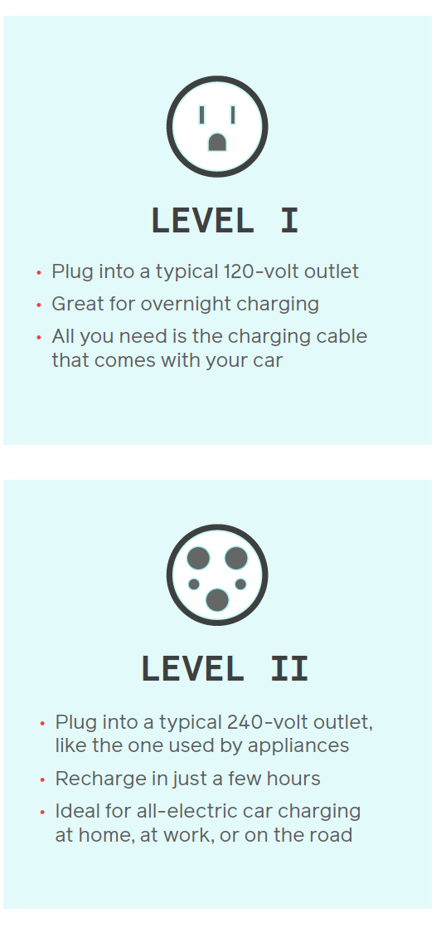
Levels 1 and 2 charging speeds are most common in residential charging. 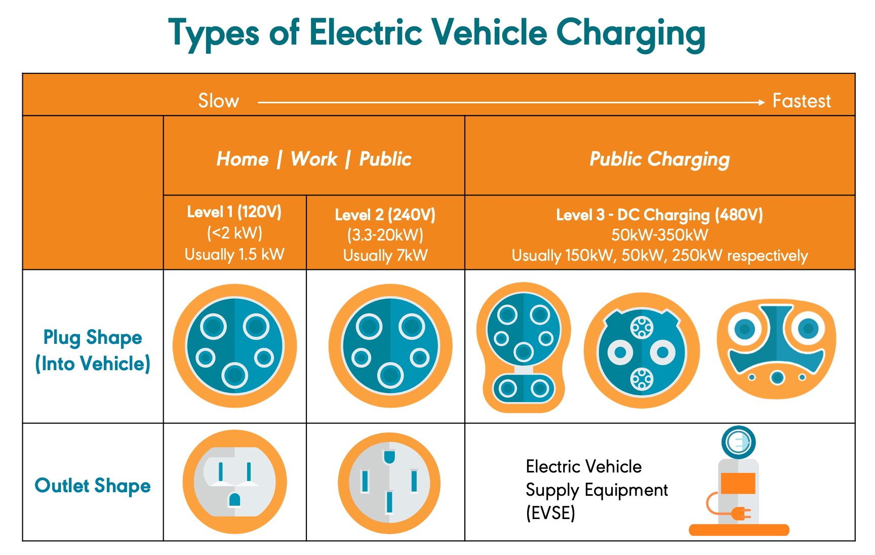

TIP!
If you are using or considering using an existing 110v/120v wall outlet in the parking lot or parking structure, be aware that the existing outlets are almost always on the same circuit. The circuit may support the charging of one vehicle. But the circuit is not designed to support the charging of multiple vehicles. If two or more vehicles try to charge, the circuit will become overloaded and hopefully, trip the circuit breaker – interrupting power to all the outlets on the circuit and interrupting any charging.

Basic Level 2 Non-Networked, Level 2 - WiFi, and Level 2 Networked
Basic Level 2 chargers are just that. They are inexpensive – just plug-in and charge. They are generally very reliable.
Level 2 Chargers with WiFi have a modest (~$100) price premium. These may be good choices for those living in townhouses with attached garages. Drivers can control their vehicle’s charging using their phone, tablet, or computer via WiFi. Level 2 chargers with WiFi allow a driver to monitor his/her charging, stop or start charging, and/or schedule when their vehicle charges or stops charging. And the driver can see how much electricity has been used.
Networked Level 2 chargers, sometimes called “Smart” chargers, are connected to a network (in the cloud). Many networked chargers can authorize access - who charges, when they charge, and how much they pay. Networks track usage and are capable of billing the driver. Because of their sophistication and functionality, some of these networked chargers can carry a significant premium. They require a connection to the network, most typically through a cellular modem or CAT 5/6 cable. If the parking is in the building’s basement, a cellular repeater or CAT cable may be required. (The repeater is a one-time cost.) The cellular connection is critical to the proper operation. Networking costs are typically included in the monthly or annual Network Fees and vary by network.
As part of the Department of Energy’s VCI-MUD project, several lower cost solutions and systems were identified. Each solution has unique functionalities or a combination of functionalities that lend themselves to Multi-Unit-Dwellings.
With Level 2 charging, plug-in hybrids and older limited range EVs need to charge about 2 ½ hours to 3 ½ hours each day. Today’s longer-range 200+ mile EVs only need to charge every 3 or 4 days and their typical charging time is 4 ½ to 5 hours.
WHY THIS IS IMPORTANT: If the building only has sufficient power for one Level 2 charger, and the typical vehicle will be fully charged in 3 to 4 hours, that power, if managed or shared, could charge 3 to 4 vehicles each night.

